Landgate API Test

Abstract

Acknowledgements

Table of Contents

* Landgate API Test
  + Abstract
  + Acknowledgements
  + Table of Contents
  + List of Figures
  + List of Tables
  + Introduction
    - Landgate
    - Web Services
    - Spatial Web Services
      * Open Geospatial Consortium Web Map Service
      * Open Geospatial Consortium Web Feature Service
      * Google Maps Engine
      * Esri ArcGIS for Server and ArcGIS ReST API
  + Literature Review
    - Similar Work
    - Web Service Quality and Discovery
    - Web Service Evaluation
    - Acceptance
  + Materials and Methods
    - Generalised Workflow
    - Data Model and Structures
      * TestCampaign
      * TestMaster
        + TestEndpoint
        + LocationTest
        + NetworkTest
        + PingTest
      * ReferenceObject
      * Vector
      * CampaignStats
    - iOS Mobile Application
      * Mobile Application Design Principles
      * iOS Application Architecture
      * Swift Open Source Packages
        + Realm Mobile Database
        + Transporter State Machine
        + Reachability
        + KDCircularProgress
      * Hardware
    - Google Apps Engine Web Service
      * Web Service Design Principles
      * Python Application Architecture
      * Python Open Source Packages
        + Matplotlib
    - Other Applications Deployed
      * Paw
      * Atom
      * Xcode
  + Results
  + Discussion
  + Recommendations
  + Future Work
  + Conclusions
  + References
  + Appendix A
    - Web Service Requests
  + Appendix B

List of Figures

List of Tables

Introduction

Anoverviewofthereport. Acleardescriptionofyouraimsand objectives,andthecontextoftheproblem or situation. Thescopeofyourinvestigationaswell asanylimitations. Ifneeded,abriefhistoricalbackground (withsubheadings)ofsignificantevents leading up to the present investigation. Iftheexplanationofthecontext istoolong,makeita separatesectionandcall it Background/Context/Definitions/Key Terms. Ifyouneedtoprovideananalysisof existingresearch,makeaseparatesection titled Literature Review. Usethepresenttensetooutlinethe problemandyouraims. Usepasttensetodescribeevents thathaveoccurredwhengivingbackground information or context.>

Landgate

Landgate is the trading name of the Western Australian Land Information Authority, the statutory authority given charge of maintaining the state's land and property information system {Anonymous:2004tv}. The organisation is the inheritor of the mandate of various incarnations of the Department of Lands and Surveys, dating back to the original Survey Office in the 19th Century.

Landgate's role incorporates managing property ownership and transfer records, as well as property valuations to government agencies {Anonymous:x1iQOCOB}. Vital to society in the connected age, Landgate is Western Australia's leading spatial data agency. Landgate has successfully commercialised spatial data creation and access. Their cumulative efforts considerably lessened their dependence on funding from the state government. The success of this strategy has lead to a projected 5% increase in the number of datasets served through the 2015/16 financial year {Anonymous:2015va}.

[ ] Diagram organisation of Landgate, WALIS etc.

The Western Australian Land Information System (WALIS) is a partnership between government agencies, the private sector and the community. Their aim is to improve access to location information for the betterment of the Western Australian community {LocationInformationStrategyProgramCoordinationTeam:2012te}. The Shared Location Information Platform (SLIP) is WALIS's spatial data portal, the Western Australian government's Spatial Data Infrastructure (SDI), managed by Landgate. The portal presents datasets owned and maintained by authoritative agencies, standardises data formats and simplifies access. SLIP Future is WALIS's programme to revamp the original SLIP Enabler portal and infrastructure {Anonymous:2014ww}. The custom built and open-source based infrastructure was deemed incapable of handling projected usage and implementing new features. WALIS built a new platform around Google's Software as a Service (SaaS) Google Maps Engine (GME). The new environment offered significant advantages in reliability, scalability and feature set {Anonymous:2014ww}.

In January 2015, Google announced the deprecation of Google Maps Engine {SLIPFuture:2015uc}. Further, they planned to shutter the service entirely by the end of January 2016 {Anonymous:2015tg}. Landgate and WALIS were left in search of a new provider for the SLIP Future programme. ESRI aggressively sought the business of GME refugee organisations {Anonymous:7YAzB1Ym} offering free software replacements and membership to business partnership programs. In July 2015, Landgate selected Esri's ArcGIS Server and Portal as the replacement for GME {Anonymous:2015uc}. Web services offering datasets in Esri's ArcGIS REST APIs will replace GME's API through a transition period through the end of 2015 and beginning of 2016.

Web Services

[ ] introduce more

The development of powerful and flexible web services was the foundation that allowed the mobile web to blossom. Web services enable interaction between computer systems over a network. One system may call on another to provide data or a service without requiring a human user to mediate the interaction {Anonymous:bRhwymPh}. Mobile devices have limited processing power and storage available, so off-device storage and processing empowers on-device applications.

Service Oriented Architectures (SOA) is a standard governing software design that aims to compose a software product from loosely coupled, and hence replaceable, components {Endo:2010wf}. Designers commonly employ this pattern as a method for distributed computing {Palacios:2011eo}. A set of descriptive XML documents, such as Web Services Description Language (WSDL), enable service builders to publish to service registries and then consumers to find and bind to services suited to their needs. Communication is carried out with XML-based messages based on the Simple Object Access Protocol (SOAP), another highly capable standard.

Representational State Transfer (ReST) services are much easier to develop and consume {Castillo:2011ve}. The adoption of ReSTful services has led to an explosion of data available on the web, particularly with mobile applications in mind as the end consumers.

Spatial Web Services

[ ] Introduce spatial web services

Deliver Spatial data over What is spatial data Who are the Geospatial Consortium

**Open Geospatial Consortium Web Map Service**

A Web Map Service (WMS) composes an image file from server stored vector and raster layers in response to a request in a URL. Despite their focus on returning an image file, WMS operations are still dependent upon XML, especially for GetCapabilities, GetFeatureInfo, error descriptions and layer style code.

The open source and standards driven approach meant that WMS was widely adopted and became a cornerstone web mapping technology. The standard is now quite old; it was last updated to version 1.3.0 in 2006 {delaBeaujardiere:2006vq}.

**Open Geospatial Consortium Web Feature Service**

A Web Feature Service (WFS) returns geographic vector data in GML (Geographic Markup Language, a derivative of XML) in response to a URL request. It is a more complex and capable service than WMS. If fully deployed, WFS allows external users full create, read, update and delete (CRUD) access to a geographic database {Vretanos:2005ut}.

The WFS standard is of a similar age to WMS. Version 1.1.0 is most commonly deployed, dating from 2005 {Vretanos:2005ut}. Version 2.0 from 2010 gained capability and complexity from GML3 and somewhat simpler use from stored queries but was not widely adopted in the years after its release.

[ ] Justify

**Google Maps Engine**

Google Inc.'s Google Maps Engine (GME) service enabled the creation of more sophisticated web mapping services on top of the Google Maps interface. Whereas the familiar Google Maps application only allowed one or two additional map layers to be displayed, Google Maps Engine could host many hundreds of datasets in the cloud and perform multi-layer geographic analysis {Anonymous:s3eShq99}. The full version was a true enterprise application and cloud service, with off-the-shelf or bespoke solutions created to suit a client's needs. The scalability and reliability of Google's service were a significant attractor to geospatial providers, such as Landgate.

From the 22nd of November 2014, Google redirected GME website bound traffic to their Google Maps for Work service {Anonymous:A_DLJUOY}, a more streamlined approach to providing enterprise mapping solutions than the previous five separate products.

In a commercial decision, Google Inc. announced the deprecation of the GME API on the 29th of January 2015 {Anonymous:2015tg}. Google shuttered the service on the 29th of January 2016.

**Esri ArcGIS for Server and ArcGIS ReST API**

ArcGIS for Server is Esri's enterprise level product for intra/internet GIS and provisioning web services {Anonymous:BHtz-GD9}. ArcGIS for Server has a long development history and has been an established (or entrenched rather) product in geospatial enterprises for many years.

The ArcGIS REST API exposes ArcGIS for Server data and functions as web services. This modern API has been fully developed since 2010 {Anonymous:hoTu0aor}. ArcGIS for Server's age means it is also fully capable of supporting older web service standards such as SOAP.

Literature Review

Similar Work

Web services are widely studied. However, the scope of applications for web services is broad. There are, therefore, few studies that examine the intersection of geographic web service performance, mobile device context and an individual, state-level spatial data infrastructure. Following are a cross-section of papers with aims partially aligned to those of this work.

Hamas, Saad and Abed {*Hamad:2010tr} compare the performance of SOAP and ReST APIs on mobile devices. The measured criteria are response time and transmission size which predictably favour ReST interfaces. Their experiment design emulates a mobile device on a desktop computer; further they restrict the simulated mobile network speed. These are useful controls in an experiment designed with a very clear aim of finding which service is faster. But real world complications such as heavy network traffic or poor signal are not addressed as a factor in the outcome. As an example, SOAP's WS-ReliableMessaging protocol may reduce overall transfer time in areas with weak signal by minimising the number of failed message attempts.

Tian et al. {*Tian:2004cb} design a server-client system that can optionally compress responses to save the client's download limit or skip compression when the server is under heavy load to minimise timed out requests.

Working in the pre-smartphone era the team simulated an iPAQ Pocket PC, emulating the device on a Pentium III laptop. The laptop emulating the client is connected to the server via WiFi, Bluetooth or a simulated mobile network. To simulate the increased latency and slower connection speed of a GPRS network, they introduce another server that throttles network speed by artificially delaying messages.

Davis, Kimo and Duarte-Figueiredo {*Davis:2009hf} focus on OGC Web Map Service (WMS) optimisation for mobile devices. They elaborate a service that combines the multi-layer composition of WMS with the mobile device response speed of AJAX-based web maps such as Google Maps.

Their experiment implemented the proposed service and interacted with it from a custom application deployed on a Nokia N95. Given the focus on minimising data sent and received from the device, the results vindicated their hypothesis. Unfortunately, the team declined to study response time results due to "severe fluctuations" that they attributed to an overcrowded network. They conclude, by extension not experiment, that smaller volumes of transmitted data would result in faster map interaction overall.

Fowler and Peterson {*Fowler:2012bn} built a custom iPhone application to test the performance of SOAP and ReST versions of a public transportation web service in Hamburg over a typical working day. They measured response time, data serialisation/deserialisation time and response size on the device itself and returned the results to their own web service. Simple and detailed messages of significantly different response size control whether response time is dependent upon message size. The results, as is common, are given as mean and standard deviation, descriptive statistics without discussion of error responses.

Fowler and Peterson's methodology called for the mobile user to remain "fixed" while requesting and receiving the response, which we interpret as stationary. This is contrary behaviour for mobile device use. There are countless situations in which a mobile user would be active and moving while concurrently requesting data from a web service.

Provisioning web services from a mobile device faces similar network and device limitations as consuming a service from a mobile device. Nguyen, Jørstad and van Thanh {*Nguyen:2008jt} explored web service performance on an emulated mobile device. While investigating the influence of varied simulated mobile network speeds, they concluded that testing on an actual device would provide ideal settings for their network simulation. Indeed, the subsequent experiment showed considerable differences between emulated and real network speed influence on web service performance. Even after modifying their simulated network speed to approximate real world network speed the difference is significant.

Hussain, Wang and Toure {*Hussain:2014ce} test the response time and throughput of a variety of real world web services over DSL, WiFi and LAN internet connections. Results are simplified to descriptive statistics, average, minimum and maximum response time.

Hussain, Wang and Toure discuss some tests with unusually long response times and speculate that it may be due to other web traffic. The specific time or other conditions of these particular tests are not elucidated. In fact, the methodology is not sufficiently detailed to provide all the parameters used in web service requests. Repeating their experiments will likely produce different results.

Yang, Cao and Evans {*Yang:2013ff} demonstrate that WMS servers struggle with heavy loads of simultaneous requests. They recorded response times to 1, 5, 10. 30, 50 and 100 concurrent requests to six important WMS servers. They found that response times increased with the number of requests until many servers either blocked all incoming requests to handle the load or simply timed out. They make several recommendations, particularly regarding parallel requests and processing. Most helpfully to this study, a simple progress bar to indicate to a user that their request is still being processed.

The emergence of ReSTful web services engendered many studies comparing performance to entrenched SOAP services. Few experimental designs take advantage of SOAP's inherent advantages, i.e. a message layer and orchestrated distributed computing, such a design would allow SOAP APIs to be compared more favourably with ReST APIs.

Castillo et al. {*Castillo:2011ve} compare ReST and SOAP service implementations as the intermediary messaging layer for a genetic algorithm and a fitness evaluator. They also present one of the few papers to elaborate the advantages of the older SOAP API standard against a ReST API, but their experiment doesn't build on this. Their proof of concept methodology introduces a useful control, requests via SOAP and ReST send strings of either 100 or 1,000 characters. The proportional time difference between large and small requests controls whether the response time depends upon the amount of data sent and received, illuminating how much response time overhead is due to the API employed.

Like other researchers, Castillo et al. relate the results of their performance tests as average response time with a margin of error. They discuss accuracy, but this is in terms of their genetic algorithm's accuracy, not the error rate of the web service API.

Kanagasundaram et al. {*Kanagasundaram:2012wv} expose a student database as a resource and perform Create, Read, Update Delete operations over SOAP and ReST web services. The comparison of response time between different operations leads the team to propose a hybrid SOAP and ReST web service that incorporates the security and reliability aspects of SOAP with ReST APIs' ease of development.

The experiment design places the client and server processes on separate cores of a single processor. This works well as an experimental control but comes at the expense of measuring real world performance. Furthermore, the results obtained by Kanagasundaram et al. {*Kanagasundaram:2012wv} are averaged response times from experiments repeated until they achieved a 95% confidence level. But not all are presented in the paper, only a select subset. Presumably messages resulting in errors were excluded from the averaged results.

Expedients such as simulated mobile networks or emulated mobile devices can be more easily understood when considered in the context of testing a production server. Stress testing and automated test case generation, for example, both benefit from a quantity of tests unachievable with a few handheld devices. Services such as Load Impact {Anonymous:0z5u-mT-} emulate thousands of mobile users on a variety of devices with a range of network connectivity.

Mobile application testing is a rapidly growing field. Gao et al. {*Gao:2014fp} identified four classes of mobile application testing approaches. Emulation-based testing, as seen above, where a device simulator runs on a desktop computer, is commonplace as emulators ship with most app development environments. Device-based testing runs the application and its services on a range of real devices to find edge case failures. Cloud testing suits large-scale tests scaleable to requirements. Crowd-based testing employs volunteers or contractors to test apps and can reach reasonable scales, they note that tests may not be completely thorough.

Yan et al. {*Yan:2012uf} built a cloud testing suite, an approach they called Web Service - Testing-as-a-Service (WS-TaaS). Their experiment showed that cloud tested web services were capable of responding to significantly more requests than one tested on a single desktop computer. Most likely due to the limited bandwidth and processing power of the single testing node.

Web Service Quality and Discovery

[ ] Citation to support topic sentence

Automating web service discovery is a much more active field of research with the aim of supporting semantic web development. An application should be able to bind the web service without supervision from the end user. How then, though, should the application choose which web service to employ from the multitude available, also without requiring user intervention. The investigators below are proponents of systematically and automatically applied quality metrics as a basis for deciding which web services should be bound.

Palacios, Garcia-Banjul and Tuya {*Palacios:2011eo} surveyed Service Oriented Architecture literature to find articles focussed on dynamic binding. 57% of the 33 articles detected faults in web services and thereby excluded non-responsive services.

Orion, Marco and French {*Oriol:2014kq} reviewed the state of the art in quality of service models for web services, surveying 65 papers written between 2001 and 2012. They showed that most researchers were assessing web services quality in terms of availability (essentially the probability a request will receive a response) with 94% of surveyed papers defining the metric. Response time was second place at 83% coverage and accuracy third with 62%.

Wu et al. {*Wu:2011kk} propose web service registries evaluate the quality of services they expose. Service downtime, mismatches between catalogued metadata and current capability or inconsistencies when registered in multiple catalogues can lead to the selection of a suboptimal web mapping service. The catalogue service periodically interrogates an OGC WMS testing all operations listed in its GetCapabilities document. Successful tests decrease the frequency of future tests while a lack of response increases the frequency.

Wu et al. model quality factors using a hierarchical tree, proposed by Hanwu Zhang, one of the authors in their Ph.D. dissertation from 2008 (reference not found in English translation). This is a helpful concept for automated quality analysis as branches in the hierarchy can be weighted differently, emphasising categories of metrics (the "leaves") over others. Unfortunately, Wu et al.'s automated analysis stops after comparing the most recent response time to a weighted average of previously recorded response times. They go on to assess map data quality through a survey method. A GUI program presents returned data to an expert user for assessment and scoring out of five on a series of quality metrics.

Miao, Shi and Cao {*Miao:2011dh} build upon Wu et al.'s method of adaptable testing frequency by halving test intervals when the response time is greater than the average of earlier tests. They go further to parameterise the proportion of failed requests. Their process is explained well in a flow chart, omitted from many similar papers.

Miao, Shi and Cao developed a C based program to crawl 100 WMS servers to measure their performance and stability as per their procedure. The conference paper referenced here omitted a table listing the servers assessed. As with Wu et al., the team leaves data quality assessment to a survey of expert users.

Web Service Evaluation

The OASIS Web Services Quality Factors {Kim:2012wm} defines six quality factors with 28 sub-categories.

1. Business Value Quality - the value arising from using a web service as compared to the cost.

2. Service Level Measurement Quality - the service responsiveness from a client's point of view, including

time and success criteria.

3. Interoperability Quality - the degree to which a service conforms to appropriate standards.

4. Business Processing Quality - the service's reliability for business use considering transmission

integrity and integration with other processes.

5. Manageability Quality - management processes to ensure web service quality.

6. Security Quality - the service's ability to prevent intrusion, interception or destruction of the service

itself or its messages.

Taken all together these represent all factors that affect a client's decision to consume a web service. The scope of this study is limited to those aspects of Landgate's service that affect their suitability for use on mobile devices. The business process and value, management, interoperability and security factors cannot be tested with a mobile device. These are more suited to desktop studies and surveys of existing clients. Only Service Level Measurement Quality is within the purview of this study. The sub-categories include;

1. Response Time - the time interval between the transmission of a request and the receipt of a response. The

total time is composed of the time taken for the client to compose the request and decompose the response plus

the network transmission time to and from the server plus the time taken for the server to process the request

and formulate a response.

2. Maximum Throughput - the maximum number of requests a service can reliably respond to in a unit of time.

3. Availability - the proportion of time the server is operational, the complement of service downtime per

measured time.

4. Accessibility - the probability of the web service can be reached when the system is operational,

quantified as the number of received acknowledgement messages divided by the total number of requests.

5. Successability - the probability of receiving a successful response to a web service request, the number

of responses divided by the number of requests.

We propose to track these factors through a series of frequent but irregularly timed tests from a mobile device deployed in situations common to the mobile network milieu.

Acceptance

Park and Ohm {*Park:2014jp} used survey data to construct a technology acceptance model to investigate users' acceptance of mobile mapping applications. They found that acceptance and hence intention to use a mobile mapping service depended to a large degree upon two factors; perceived locational accuracy and processing speed. Park and Ohm defined perceived locational accuracy as how well users envision their location in the map, essentially the degree to which mapped features correspond with a user's mental model of the world and where they are in it.

Materials and Methods

Generalised Workflow

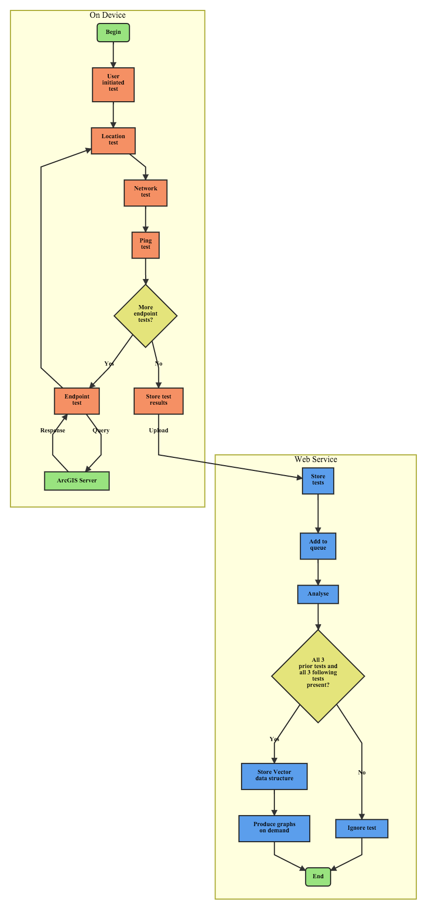

[ ] User initiated test

[ ] preconditions

[ ] sequence

The client / server interaction has a number of failure points, it is important for this work to record failed requests as these affect a service's suitability for mobile network traffic. The device may be unable to reach the endpoint at all due to a total lack of connectivity (recorded as response code "0") or if a TestEndpoint is interrupted before conclusion. The request may be rejected by the server, these are the 400 series response codes (for example the common 404 code for a missing resource or 403 for failed authorisation). A server-side fault that prevents a proper response is assigned a 500 series response code (such as the very general 503 Server Error code). Should the device fail to reach the server, or the server respond with a 400 or 500 code the iOS LandgateAPITest app records the TestEndpoint as a failure. These are referred to as "On Device Failures".

Note that 300 series response codes, the resource moved or redirect codes, are not considered failures. The test continues to the redirected resource where it will eventually earn a 200 success code or one of the failure codes.

[ ] Store on device

[ ] User initiated upload

[ ] web app record, queue

[ ] Analyse

If the response received by the iOS app is identical to the reference response stored in the web app then we consider the entire test successful. The iOS application may assume a test is successful given it receives a 200 response code from the Landgate server. Often though OGC servers will respond with a 200 code but send exception text in place of the response data. Tests that fail at this stage are referred to as "Reference Check Failures" and have an appropriate flag set on the record on the web application database.

During execution of the Analyse function the web app records the percentage of reference check tests successful for each test type. Should a test type return less than 5% successful reference checks we assume that there is a process error or an incorrect reference object and disregard the test type entirely. Such tests are flagged False for their "ReferenceCheckValid" property to allow them to be filtered out.

Data Model and Structures

**TestCampaign**

A unique and human-readable string identifier which groups many TestMasters into a single campaign. Theoretically representing a unit of work for a single client.

The TestCampaign class in the web application has no properties other than its name. It serves as the ancestor key for all TestMaster, Vector and CampaignStats objects, simplifying their retrieval from the datastore. In the case of this work the test database used "test_campaign" and the production database used "production_campaign" as the test campaign names.

**TestMaster**

All TestMasters and their children inherit from the ResultObject superclass in both the web iOS applications. In this manner they inherit the same properties of datetime, testID, parentTestID and so forth. This is for the sake of convenience and avoiding repeating code.

**TestEndpoint**

The main focus of the study, TestEndpoints request a set response from the Landgate server.

Each TestMaster will record dozens of TestEndpoints.

TestEndpoints are stored in the iOS application database as EndpointResults. For the sake of differentiating them in the web application Python code they retain the TestEndpoint nomenclature.

**LocationTest**

The LadgateAPITest iOS app requests a 10 metre accuracy for location fixes. This is not guaranteed, should the device be unable to locate with the desired accuracy it will report what it can after timing out. As with all GPS devices the environment affects location accuracy, particularly when testing indoors. Looser GPS accuracy saves the device's battery power which otherwise would be wasted in trying to acquire a more accurate location fix.

The web application and iOS application databases store each LocationTest's outcome as a LocationResult.

**NetworkTest**

The iOS device reports its mobile network connection type through the Telephony framework.

The result object for a NetworkTest is a NetworkResult.

**PingTest**

The result object stored in the database for a PingTest is a PingResult.

**ReferenceObject**

ReferenceObjects hold the true version of the Landgate servers' response to each request. Properties of server, returnType and so forth identify ReferenceObjects from each other and allow comparison to a TestEndpoint. The reference property holds the text response, either XML, JSON or images converted to base64 text.

These exemplar responses were requested and stored on the 5th of April, 2016. This is past GME's replacement date, references for GME requests were stored in April 2016 from the first test responses in December 2015. Dynamic parts of responses were excluded from the final ReferenceObject, for example any date or time value that changes between requests.

The administrator uploads text files containing ReferenceObject references to the web application's code repository. A request to the \StoreReferences endpoint enqueues a task to add new and replace old ReferenceObjects with the text file contents.

**Vector**

The web application's Analyse function parses each TestEndpoint object and attempts to generate a new Vector object. Vectors encapsulate the LocationTest, NetworkTest and PingTest immediately preceding the TestEndpoint along with those immediately following it, retaining pointers to these objects. The function determines the change in Location, Network conditions and Ping response time and takes them as a proxy for the mobile device's changing connectivity environment through the endpoint test.

The logic to retrieve the six related subtests from the datastore is as follows;

1. Query only those records specific to the subtest type (LocationTests, NetworkTests or PingTests)
2. Retrieve only results with the same TestMaster key as the TestEndpoint
3. Filter results to only those with a datetime property less than the TestEndpoint's datetime for the three preceding subtests (or greater than for the three following tests)
4. Sort the results by their datetime, descending for preceding subtests and ascending for following subtests
5. Return only the first result, that being the closest in time to the TestEndpoint

If any one of the six subtests are absent the Vector object can not be reliably created and the process is aborted. The TestEndpoint is marked IMPOSSIBLE to prevent any further automated attempts at analysis. Such objects are not considered any further in this study. Situations like this may arise where the test was cancelled partway through and not all three following subtests were completed.

The Haversine distance formula gives a great circle distance travelled between two LocationTests (essentially a straight line at these scales). Dividing this result by the time difference gives an average speed in metres per second. The time between two LocationTests is not the same as the TestEndpoint's total elapsed time. The interval is greater as it allows for NetworkTests, PingTests and the duration of the LocationTests themselves.

The generation of mobile network is here taken as a proxy for connection speed. For example LTE is a fourth generation network and here assigned 4.0 for a networkClass property, where HSDPA would be assigned 3.5, CDMA 2.5 and so on. We assume that wifi is generation 5.0 due to its higher potential connection speed. Subtracting the following networkClass from the preceding one gives a networkChange value, positive reflecting improving network and negative degrading network connectivity.

The change in response time for a HEAD request to google.com.au before and after an EndpointTest is another proxy for change in network connection speed. Subtracting the following response time from the preceding response time gives a positive pingChange value for improving network speed and a negative one for degrading speed.

The Analyse function also performs the reference check. It assigns the Vector's referenceCheckSuccess property a True value if the TestEndpoint's response data contains the ReferenceObject's reference text or False otherwise.

Vector objects are the basis for all further analysis in this study. All graphs in this work show the Vector rather than the original TestEndpoint or its subtests.

**CampaignStats**

The CampaignStats class stores counts of TestEndpoints and other subtests, enabling calculation of descriptive statistics for a specific TestCampaign. CampaignStats updates when the iOS application uploads a new TestMaster to the database, adding new counts onto existing values. Also when the Analyse function creates a new Vector object it also updates the CampaignStats properties for reference check success.

The overwhelming majority of CampaignStats properties concern the percentage of successful reference object checks. 0% reference check success rates will exclude the entire test type from further consideration.

iOS Mobile Application

**Mobile Application Design Principles**

The LandgateAPITest iOS application should be quick to build and simple to maintain. The app's design eschews user interface flair in favour of basic views, such as the ubiquitous UITableView. This has the beneficial side-effect of making the app familiar and easy to use for a braod range of the community.

Where possible, open source libraries should replace handwritten code. There being no point to reinventing functionality already well developed and freely available. A common pattern in modern app development, community supported code libraries fill narrowly focussed functions. These are easily incorporated into an iOS project through dependency management applications and community code repositories such as GitHub.

LandgateAPITest is not a privacy focussed app. The application collects data that many would consider intrusive, such as location or mobile network connection details. Without this information the application would not fulfil its objectives. The app's help text encourages users who find such invasiveness unacceptable to uninstall the application.

The application is also a heavy user of the device's battery and mobile network downloads. These are similarly unavoidable, being core to the application's function. The help text highlights that users may upload a test while on a wifi network to avoid data charges for uploading a TestEndpoint's response data.

Given these two points users could be justly concerned that the application would be a noticeable drain on their battery and data plan. We address this issue by only testing when the application is in the device's foreground, that is on the screen while the device is awake. Should the application be sent to the background it immediately enters an abort state, cancelling active tests and storing what results it has to the database. This can be triggered by the user selecting a different app, clicking the Home button, or by an interrupting phone call.

**iOS Application Architecture**

Apple Inc. advocates the Model-View-Controller (MVC) design pattern in object-oriented code. A controller class intermediates all interaction between the data model layer and the views on the device screen. LandgateAPITest follows this pattern by implementing viewcontroller classes for each screen presented to the user.

The majority of the applicaiton's logic does not reside in viewcontrollers however. It is a common problem in MVC pattern design that the controller classes amass logic to the point of becoming unwieldy and difficult to maintain. LandgateAPITest's viewcontrollers call upon the SingletonTestManager and SingletonUploader classes when the user initiates a test or an upload to the LandgateAPITest web app respectively.

Firing requests at Landgate's endpoints concurrently, rather than synchronously, would give unreliable response time results. Analysis would not be able to determine what proportion of response time was a factor of the device resolving multiple threads of computation. To avoid this complication LandgateAPITest's iOS app uses a state machine architecture.

[ ] State machine UML diagram

Functions are completed sequentially, the completion of a test fires an event function causing the application to change state and thereafter perform different functions.

When the user initiates a test the SingletonTestManager class switches to its prepareForTest state where it checks preconditions and creates a TestMaster object. From there the SingletonTestManager enters a loop; testing location, network, ping to google.com.au and then testing a Landgate endpoint (a TestEndpoint) and back to location. The loop continues until the TestMaster's queue of TestEndpoints is exhausted, whereupon the TestMaster and all its subtests are written to the device's database. Each state performs distinct actions and does not interfere with tests preceding or following as none may start until the earlier test has successfully finished.

At any time the state machine may abort the loop if the preconditions are not met, the app leaves the foreground, or the battery is exhausted. It immediately skips to the post-test state and attempts to save the test results gathered to the device database. Notably, any test (endpoint, location, network or ping) cancelled part-way through is aborted and marked as "Failed On Device."

Uploading in the background of the applicaiton uses a similar pattern. The SingletonUploader class changes state from "Ready" to "Uploading" and thence to "Success" or "Failure" depending on the response code from the web app. It settles back to the "Ready" state once its upload queue is emptied.

**Swift Open Source Packages**

**Realm Mobile Database**

The Realm open source mobile database {realmrealmcocoa:2016vs} is a much simpler on-device storage solution than the proprietary Apple Inc solution. LandgateAPITest stores all test results in a Realm database file.

**Transporter State Machine**

Denis Telezhkin's Transporter library {DenHeadlessTranspor:2016ta} offers a straight-forward state machine implemented in Swift, available under the MIT licence. LandgateAPITest relies upon Transporter state machines for the TestManager class and the TestUploader class.

**Reachability**

Ashley Mill's Reachability library queries the device to determine whether and how it is connected to a network {ashleymillsReachabi:2015to}. LandgateAPITest depends upon Reachability's response in two areas. Firstly, having a network connection is a prerequisite to starting a test, either through wifi or 2G, 3G or 4G mobile network. Secondly, the iOS standard telephony libraries report a mobile network connection regardless of whether there may be an overriding wifi network connection. LandgateAPITest checks Reachability beforehand for a wifi connection.

**KDCircularProgress**

Kaan Dedeoglu's KDCircularProgress library initiates a progress indicator that fulfills a circular ring as the task approaches completion {kaandedeogluKDCircu:2015vt}. LandgateAPITest uses KDCircularProgress to show the percent completion of a test, updating the indicator each time a sub-test calls its completion delegate method. The library was chosen as it aligned with the design aesthetic of recent iOS releases.

**Hardware**

All tests were performed on an Apple iPhone 6S, model A1688 (a.k.a. iPhone8,1), with 64GB of storage. The standard device comes with a range of mobile radios across a number of bands; LTE, HSDPA, CDMA, GSM, EDGE, wifi radios a/b/g/n/ac and GPS and GLONASS receivers {Anonymous:uf}.

|  |  |
| --- | --- |
| Campaign Name | production_campaign |
| All Device Types | iPhone8,1 |
| All iOS Versions | 9.1, 9.2, 9.2.1, 9.3, 9.3.1 |

The operating system changed through the campaign as Apple Inc. updated their software. The first tests launched LandgateAPITest on iOS 9.1, later tests on 9.2, 9.2.1 and later still on 9.3 and 9.3.1.

Google Apps Engine Web Service

**Web Service Design Principles**

The ideal for any web service is to present the latest available data to requesters. LandgateAPITest presents statistics, maps and analysis on objects in the datastore at request time. End users need not await final reports but can check on the status of a testing campaign whenever they wish.

The iOS testing app can produce a large set of testing data in a short timeframe. Cloud computing power is capable of scaling to accommodate excess load, but at a cost. The web application acts to smooth out high load by deferring computationally intensive tasks to avoid peak load and minimise cost.

The web application should analyse TestEndpoint results and not just re-present them. Generating actionable information from pure data has much more value to the end user. Similar applications produce appealing graphs with little scientific merit. LandgateAPITest's charts, while less visually gripping, offer in depth analysis and proper scientific methodology.

**Python Application Architecture**

Google App Engine Python applications derive their basic functionality from the webapp2 open source library {Welcometowebapp:2011vk}. Developers define web app endpoints and map them to Python classes, so landgateapitest.appspot.com/database maps to the Database class in Python code. Then the HTTP method maps to functions within that class. A POST request to the /database endpoint fires the Database class's post() function adding the request body to the databse. A GET request calls the get() function and downloads a TestMaster record to the requester.

Functions may call for a task to be enqueued, whereupon the GAE system will fire the specified request at a later time, ideally when processor load is minimal. A successful POST request to the /database endpoint queues an /analyse endpoint GET request as one of its last tasks. Similar tasks which are anticipated to consume more than trivial resources are deferred as queued tasks in LandgateAPITest, such as importing reference text files to the datastore or updating model schema.

Google App Engine applications may use any of Google Inc.'s several cloud data storage solutions. LandgateAPITest uses Google Cloud Datastore, a NoSQL database quite distinct from relational databases in that it does not store all records as atomic rows in tables, rather as schema-less objects in distributed documents.

**Python Open Source Packages**

**Matplotlib**

Well known in academia, Matplotlib is an open source Python library capable of producing detailed graphs from complex datasets {matplotlibmatplotli:2016vd}. LandgateAPITest's web app leveraged Matplotlib to build graphs of up to the minute Vector object data queried from Google's Cloud Store. Programmatically building the figures in this report allows them to be recreated on demand with the latest information from testers.

Matplotlib's analytical power is enhanced when paired with Numpy {NumPyNumpy:2016vy}. A mathematically focussed library, most useful in LandgateAPITest for its arrays, which are much more analytically oriented than generic Python list collections.

**Leaflet**

The LandgateAPITest web application offers a heatmap of test locations. More precisely, the map shows each Vector object's LocationTest prior to the EndpointTest. Leaflet {Agafonkin:2016wz} is a lightweight JavaScript mapping library, it is ideal for a simple application such as this.

Visualising 16,000 test locations as generic markers would result in a confusing map. The Leaflet.heat {Agafonkin:2015ww} library generalises multiple points into a single heat map layer. Closely clustered tests are represented by warmer colours, dispersed ones by cooler colours. OpenStreetMap tiles comprise the basemap, available under a CC BY-SA open licence and built by the community of OpenStreetMap contributors.

Other Applications Deployed

Besides code incorporated directly into the product applications, there were several other applications instrumental to development.

**Paw**

Keeping track of 46 ReST requests, each with minor variations from its neighbours, required more than a handwritten list. Paw (version 2.3.3) {Anonymous:tn} is a Mac application designed for testing ReST requests. It simplifies the process of composing the request and its query components. Its most helpful feature is its Swift NSURLSession code output, suitable for directly pasting into an iOS application repository. The code in LandgateAPITest's EndpointTester class where it fires a request to the Landgate server is derived from Paw's example code.

**Atom**

Atom (version 1.7.2) {atomio:vz} is Github Inc's open source text editor used primarily for LandgateAPITest's Python web app development. The Github community has built a plethora of extensions expanding the application's capabilities far beyond the average plain text editor. This entire report was drafted in MarkDown styled plain text in Atom.

**Xcode**

Apple Inc's Xcode Integrated Development Environment (IDE) {Anonymous:3QN3N1hm} is the orthodox application for developing apps for Apple machines. LandgateAPITest's iOS app was entirely built in Xcode version 7.3.

Results

Test Regime

The "production_campaign" featured two main pushes of testing. The first in December 2015 through to January 2016 tested Google Maps Engine endpoints before their shutdown. The campaign's main thrust took place in March 2016 where the majority of tests queried the old OGC endpoints and the new Esri endpoints.

The user initiated 284 TestMasters resulting in 16,144 TestEndpoints with similar numbers of LocationTests, NetworkTests and PingTests.

| **Test** | **Count** |
| --- | --- |
| Count Test Masters | 284 |
| Count Test Endpoints | 16144 |
| Count Location Results | 16391 |
| Count Network Results | 16391 |
| Count Ping Results | 16345 |

There were three theatres of action in the campaign. Each test is mapped in a Leaflet web map using the location of its Vector's PreTestLocation (the LocationTest completed before the TestEndpoint began). Visualising 16,000 points would result in an ineffective map, so here closely clustered points are generalised into a heat map. A beneficial side effect of generalisation is to obfuscate precise locations.

The majority of tests took place in Sydney, NSW and its environs. In particular the regular commute over the harbour to the Central Business District, and the roads and freeways to neighbouring cities.

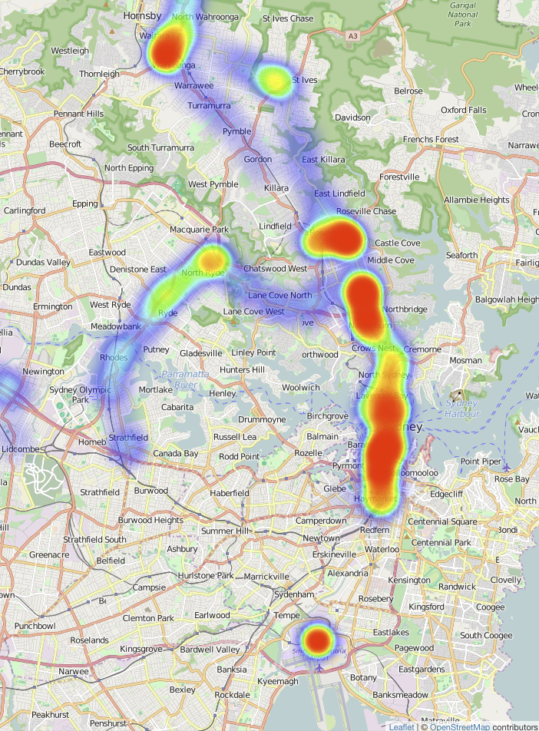

Several discrete bursts of tests took place in Bathurst, NSW and the highway back and forth to Sydney, NSW.

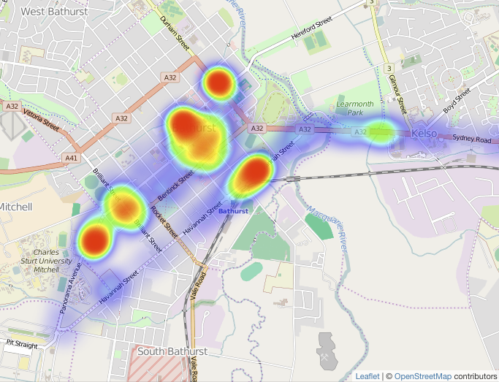

Townsville, QLD was the theatre with the least number of tests, but some interesting mobile situations involving ferry crossings and steep terrain on Magnetic Island.

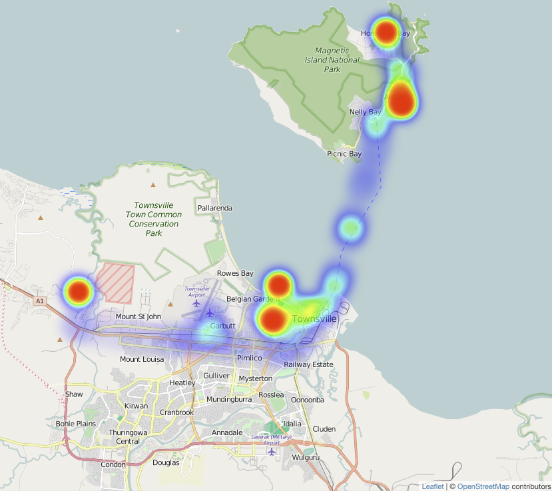

TestEndpoint Successes and Failures

Of the 16,144 TestEndpoints 15,670 were successful on device (97.06%). These were able to complete the test and received a 200 response code from the Landgate server. The 2.94% of on device failures either could not reach the server (response code 0) or received a server error response (code 500 and above).

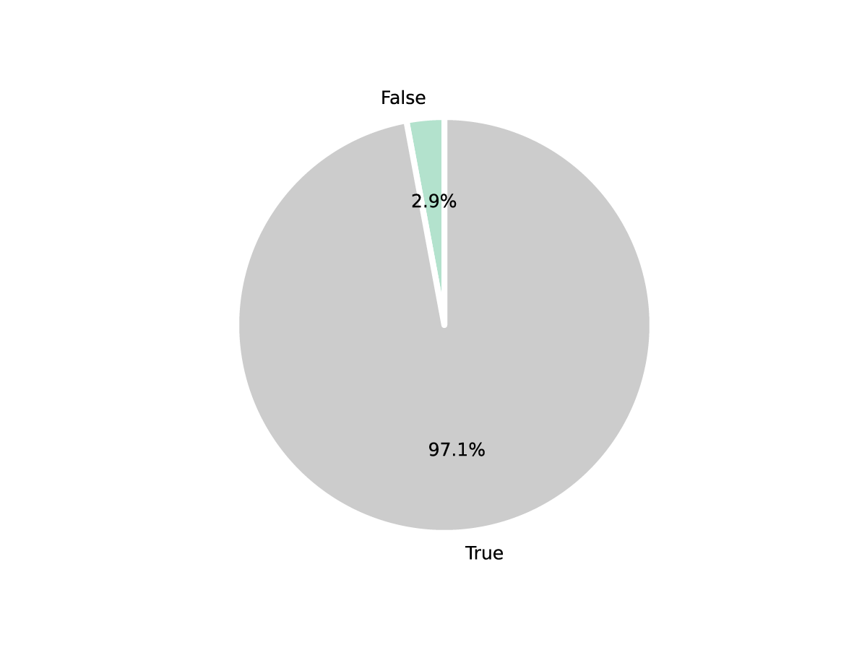

LandgateAPITest's Analyse function compared each TestEndpoint's response data to the stored reference data and determined that 13,220 of them matched, setting the resultant Vector's referenceCheckSuccess flag to True.

Closer examination of referenceCheckSuccess by test type showed 9 test types that consistently failed their reference checks (less than 5% passed). All such Vectors had their ReferenceCheckValid flag set to False to exclude them en masse from further analysis on the assumption that there was a systematic issue with their reference data. Interestingly, the GetCapabilities tests rarely passed reference checks, possibly due to timestamps buried in the XML response and reference conflicting.

| **Test Name** | **Percent Successful** |
| --- | --- |
| ESRI - BusStops - AttributeFilter - GET - JSON | 98.79% |
| ESRI - BusStops - AttributeFilter - POST - JSON | 98.20% |
| ESRI - BusStops - Big - GET - JSON | 101.06% |
| ESRI - BusStops - Big - POST - JSON | 101.03% |
| ESRI - BusStops - FeatureByID - GET - JSON | 99.00% |
| ESRI - BusStops - FeatureByID - POST - JSON | 98.76% |
| ESRI - BusStops - GetCapabilities - GET - JSON | 97.64% |
| ESRI - BusStops - GetCapabilities - POST - JSON | 98.99% |
| ESRI - BusStops - IntersectFilter - GET - JSON | 97.31% |
| ESRI - BusStops - IntersectFilter - POST - JSON | 98.21% |
| ESRI - BusStops - Small - GET - JSON | 96.98% |
| ESRI - BusStops - Small - POST - JSON | 97.89% |
| ESRI - Topo - Big - POST - Image | 99.45% |
| ESRI - Topo - Small - GET - Image | 99.32% |
| ESRI - Topo - Small - POST - Image | 100% |
| GME - AerialPhoto - Big - GET - Image | 96.97% |
| GME - AerialPhoto - GetTileKVP - GET - Image | 95.65% |
| GME - AerialPhoto - GetTileKVP2 - GET - Image | 93.75% |
| GME - AerialPhoto - GetTileKVP3 - GET - Image | 90.63% |
| GME - AerialPhoto - GetTileKVP4 - GET - Image | 90.91% |
| GME - AerialPhoto - Small - GET - Image | 86.36% |
| GME - AerialPhoto - WMSGetCapabilities - GET - XML | 0% |
| GME - AerialPhoto - WMTSGetCapabilities - GET - XML | 0% |
| GME - BusStops - AttributeFilter - GET - JSON | 83.87% |
| GME - BusStops - Big - GET - JSON | 0% |
| GME - BusStops - DistanceFilter - GET - JSON | 93.75% |
| GME - BusStops - FeatureByID - GET - JSON | 96.55% |
| GME - BusStops - IntersectFilter - GET - JSON | 90.63% |
| GME - BusStops - Small - GET - JSON | 0% |
| OGC - AerialPhoto - GetTileKVP - GET - Image | 98.85% |
| OGC - AerialPhoto - GetTileRestful - GET - Image | 98.36% |
| OGC - BusStops - AttributeFilter - GET - JSON | 0.83% |
| OGC - BusStops - AttributeFilter - GET - XML | 99.72% |
| OGC - BusStops - AttributeFilter - POST - JSON | 98.63% |
| OGC - BusStops - AttributeFilter - POST - XML | 99.45% |
| OGC - BusStops - Big - GET - JSON | 100% |
| OGC - BusStops - Big - GET - XML | 100% |
| OGC - BusStops - Big - POST - JSON | 100% |
| OGC - BusStops - Big - POST - XML | 100% |
| OGC - BusStops - FeatureByID - GET - JSON | 99.30% |
| OGC - BusStops - FeatureByID - GET - XML | 98.85% |
| OGC - BusStops - FeatureByID - POST - JSON | 100% |
| OGC - BusStops - FeatureByID - POST - XML | 99.54% |
| OGC - BusStops - GetCapabilities - GET - XML | 2.88% |
| OGC - BusStops - GetCapabilities - POST - XML | 1.26% |
| OGC - BusStops - IntersectFilter - GET - JSON | 99.73% |
| OGC - BusStops - IntersectFilter - GET - XML | 99.46% |
| OGC - BusStops - IntersectFilter - POST - JSON | 99.46% |
| OGC - BusStops - IntersectFilter - POST - XML | 100% |
| OGC - BusStops - Small - GET - JSON | 98.81% |
| OGC - BusStops - Small - GET - XML | 100% |
| OGC - BusStops - Small - POST - JSON | 99.76% |
| OGC - BusStops - Small - POST - XML | 98.83% |
| OGC - Topo - Big - GET - Image | 3.63% |
| OGC - Topo - Small - GET - Image | 3.48% |

See Appendices A and B for a list of URLs for each request.

Of the remaining tests only 79 (0.6%) failed a reference check.

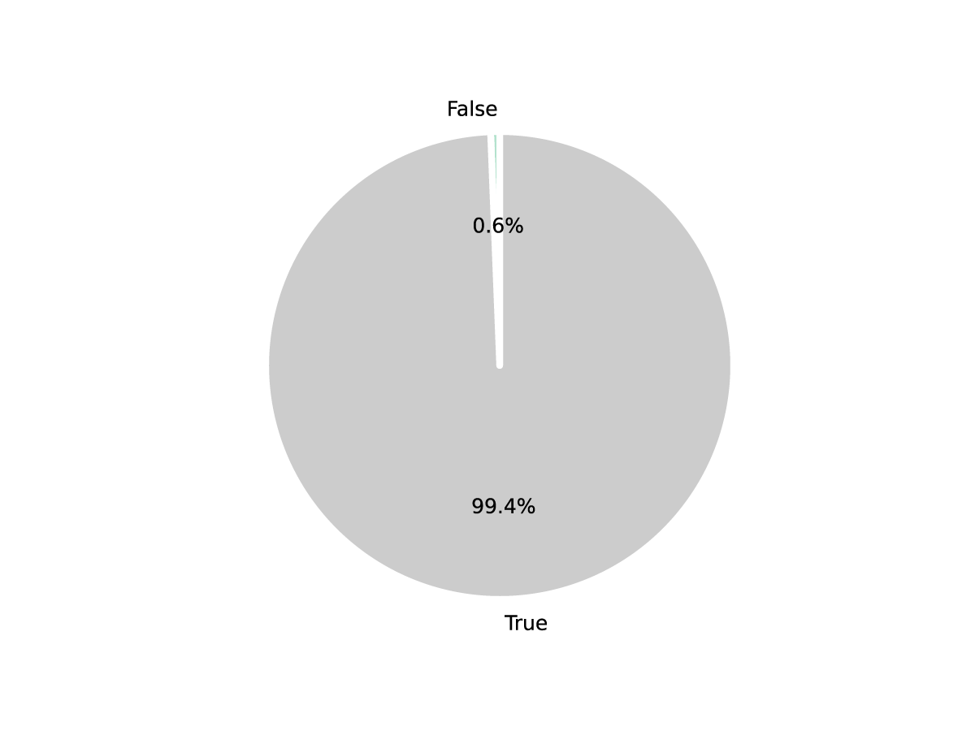

Test Characteristics

[ ] Talk about the types of tests after the filtering

[ ] Availability [ ] Accessability [ ] Successability

Discussion

Thissectionislikeashortessay – itisaconnectedseriesofsentencesthat explainandargueyourinterpretationoftheevidence. Summarise the major problem/s Identifyalternative solutions to this/these major problem/s (there is likely to be more than one solution per problem) Briefly outlineeach alternative solution and then evaluate it in terms of its advantages and disadvantages No need to refer to theory or coursework here.>

[ ] The fact that we need a logarithmic axis for response time to show the interquartile range at all indicates that the servers are suitable for a range of mobile situations. (regardless of whether OGC or Esri, XML JSON or image)

[ ] Incorrect data is delivered only 0.6% of the time, there are few mobile situations where this would be a critical hinderance. (support this somewhere)

[ ] Not a navigation server so higher time outs, longer response times (which are more a consequence of mobile networks and their hiccoughs generally) are not a major hinderance.

Recommendations

• Choose which of the alternative solutions should be adopted • Briefly justify your choice explaining how it will solve the major problem/s • This should be written in a forceful style as this section is intended to be persuasive • Here integration of theory and coursework is appropriate>

[ ] Expect a greater proportion of access to come from mobile devices [ ] Reference

[ ] continue moving away from offering full datasets for download aimed at specialists, concentrate on building new data services where applications request only those parts of specific and current interest. Landgate are to be commended for leading the way in this regard.

[ ] Favour JSON responses over XML for mobile devices, faster response time and lighter on the download limit

[ ] The public will find interesting applications for datasets, even seemingly low value data. Again Landgate's support of hackathons supports

Future Work

This work is by no means exhaustive. There remain a number of possibilities for expanding the application's reach and improving the depth of information generated from a campaign.

The most important improvement

[ ] More deeply investigate reference check failures, look for common types of failures, i.e. exceptions in response text or incomplete response data

[ ] Compare errors to Landgate’s server logs for more insight into error causes.

[ ] Three types of latency from Oasis standard

Further development work could create a version of the LandgateAPITest mobile app suitable for Android OS devices. This would broaden the base of testers available and add another dimension to the result data. Investigation could show whether the different geographic server types offer better performance and reliability for iOS or Android devices.

Success in collaborating with Western Australia's Landgate authority could be replicated with other Australian state cadastre authorities, such as NSW Land and Property Information. Given these organisations are not in competition, opportunities to learn from each other can lead to improved services for all Australian states.

Conclusions

[ ] Conclude with something that relates to the discussion

Our study's contexts are in a state of nearly constant change. Web services have lost complexity due to the dominance of ReST APIs, but the number of services available has grown exponentially. Mobile devices have more processing power, larger batteries and faster connections to the internet. There are whole new categories of mobile devices, such as smartwatches, that change the mobile device landscape. Web service evaluation studies must be continually revisited just to keep pace with change.

Similarly, service providers must prepare for a changing landscape that may not even be partially realised yet. Landgate has evolved and changed direction since early in the decade to build the SLIP Future program. They must continue to adopt new technologies and processes so as to remain relevant to their customers.

In this work we contribute to three aspects of the body of web service evaluation literature. Firstly, we test services from an actual mobile device in real-world mobile usage situations. Tests are therefore as close to the real mobile experience as possible. This contrasts with the bulk of academic literature that performs tests on desktop computers emulating mobile devices.

Secondly, we examine more aspects of the interaction between client and server than merely average response time. Examining error responses and the conditions that lead to them will give valuable insight into mobile-specific situations likely to result in errors.

Lastly, our examination of a single service provider, Landgate and WALIS's SLIP service, should produce practical and actionable recommendations to improve its suitability for mobile users.

References

Appendix A - Web Service GET Requests

Google Maps Engine

| **Number** | **URL** |
| --- | --- |
| 1 |  |

Open Geospatial Consortium Standards

| **Number** | **URL** |
| --- | --- |
| 1 |  |

Esri Rest

| **Number** | **URL** |
| --- | --- |
| 1 |  |

Appendix B - Web Service POST Requests

Open Geospatial Consortium Standards

| **Number** | **URL** | **Body** |
| --- | --- | --- |
| 1 |  |  |

Esri Rest

| **Number** | **URL** | **Body** |
| --- | --- | --- |
| 1 |  |  |